T-PaD: Tactile Pattern Display through Variable Friction Reduction

【Summary】：

In this paper we discuss the theory, design and con-struction of a haptic display for creating texture sen-sations through variations in surface friction.

【Theoretical support】：

The T-PaD is an ultrasonic device which builds on several previous efforts. Watanabe and Fukui used a vibrating Langevin-type piezoelectric actuator to create a standing wave on a flexural beam [9]. During finger exploration of the beam a reduction in friction was ob-served when the beam was actuated. This reduction in friction was used to mask surface features from the user. Watanabe and Fukui believed the reduction in friction was caused by a squeeze film of air under the finger pad. Nara et al’s work [10][11] in ultrasonic tactile displays used interdigital transducers (IDT) to create surface acoustic waves (SAW’s) on several substrate sur-faces. The SAW’s generated were in the MHz range and were shown to reduce surface friction. The shear forces from friction are transmitted to the finger through a slider interface comprising a thin tape and steel balls. The reduction in friction was believed to be the result of “decreased contact time between the balls and the sub-strate,” an air squeeze film between the balls and the substrate, and “parallel movement of the wave crest.”

【T-PaD】：

This device can reduce the coefficient of friction between the finger pad and the surface to a very low level, thereby adjusting the shear force, and we provide preliminary evidence of T-PaD that can indeed show virtual textures.

We can control the forces on the fingers that interact with the display. Knowing the position of the finger on the display allows the creation of the force pattern on the display (see Figure 3), the coefficient of friction on the surface is a function of the position of the finger. These patterns are perceived by the user as a texture.

Four following criteria: Slim Design, High Surface Friction, Inaudible and Controllable Friction

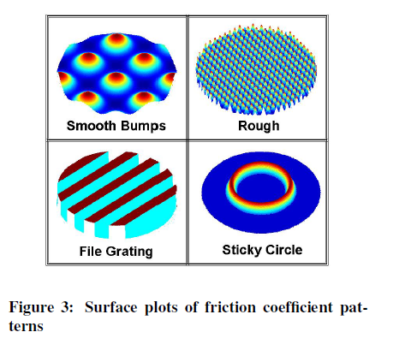

*(The device is driven at resonance, approximately 33 kHz, with an amplitude ranging from 0 to 40 Volts peak to peak. A 33 kHz, 10 Volt peak to peak signal is gen-erated by a signal generator and scaled to a computer-controlled amplitude using an analog multiplier chip (AD633AN). The signal is amplified and then stepped up by a 70V line transformer. In our implementation, a computer-generated output level of 5 volts DC, corre-sponding to a 33KHz signal amplitude at the piezo of 40 V peak-to-peak, resulted in approximately a ten-fold re-duction of the coefficient of friction. The amplitude of the 33KHz signal can be modulated either temporally or with respect to finger position to produce interesting sensations across the surface of the disk.)*

【Experiments】：

**Variable Friction Experiment**

**Procedure：3.1 Experimental Setup+3.2 Data Collection**

A total of 18 data collection experiments were performed. During each experiment, the experimenter moved his finger back and forth across the disk in an attempt to maintain a constant normal force and speed.

**Results：**

This im-plies the effect does not begin until some point between 8 volts peak to peak and 16 volts peak to peak of piezo excitation. The limit of total friction reduction is ap-proached at excitation voltages above 33 volts peak to peak. The gradual decrease in friction coefficient with voltage increase strongly suggests the reduction in fric-tion effect is not binary, but rather is a continuous func-tion of excitation amplitude. The reduction of friction from µ = 0.9 to µ = 0.1 is strikingly noticeable to humans interacting with the display.

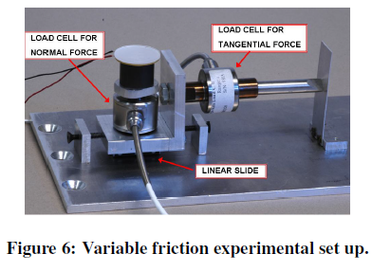 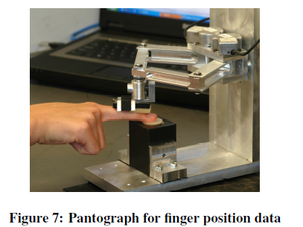

【Device Capabilities】：

Through the spatial modulation of the coefficient of friction, various textures can be created on this disk. I also tried time modulation of the coefficient of friction and found that it produced more vibration than texture. Although time modulation has the ability to produce several interesting sensations, the main goal of T-PaD is to simulate virtual textures. Since T-PaD allows the friction coefficient to change with time and spatial frequency, multiple haptic modes can be implemented.

【Conclusion】：

We have demonstrated the ability of a piezoelectric bending element to perform the function of a Tactile Pattern Display (T-PaD). The T-PaD has a broad range of controllable friction levels which are used to control shear forces on the finger during exploration.

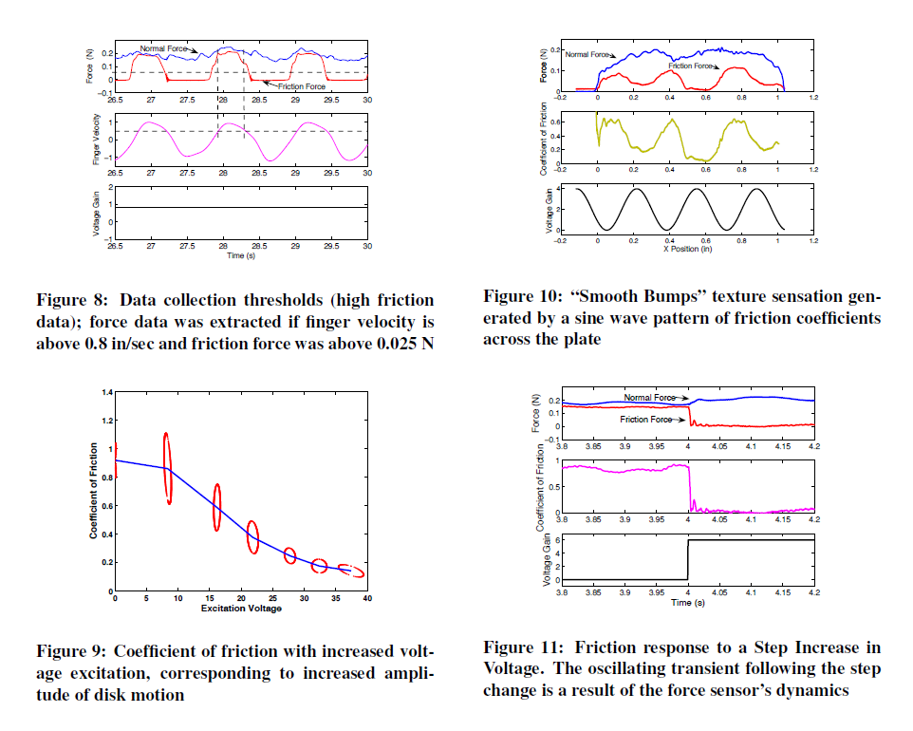

【Important Reference】:

G. Robles-De-La-Torre, “Comparing the role of lateral force during active and passive touch: Lateral force and its correlates are inherently ambiguous cues for shape perception under passive touch conditions,” in Proc. of Eurohaptics, United Kingdom.

S. Lederman and R. Klatzky, “Designing haptic in-terfaces for teleoperational and virtual environments: Should spatially distributed forces be displayed to the fingertip?” in Proc. of the ASME Dynamic Systems and Control Division, 1997.

J. Pasquero and V. Hayward, “Stress: A practical tactile display with one millimeter spatial resolution and 700 hz refresh rate,” in Proc. of Eurohaptics, Dublin, Ireland.

V. Levesque and V. Hayward, “Experimental evidence of lateral skin strain during tactile exploration,” in Proc.of Eurohaptics, Dublin, Ireland.

G. Moy and R. Fearing, “Effects of shear stress in tele-taction and human perception,” in Seventh Annual Symp. on Haptic Interfaces for Virtual Environment and Tele-operator Systems, Anaheim,CA, 1998.